

Warehouse Transfers

CONFIGURATION: Lot Level Tracking, Packaging Info = No.

Start a Warehouse Transfer* 2
Receive a Warehouse Transfer 2
Confirming a Warehouse Transfer has successfully completed 2

Start a Warehouse Transfer*
IMPORTANT NOTE: Warehouse Transfers must be STARTED and RECIEVED
Inventory < Warehouse Transfers < Start a Warehouse Transfer

Select < Start Transfer

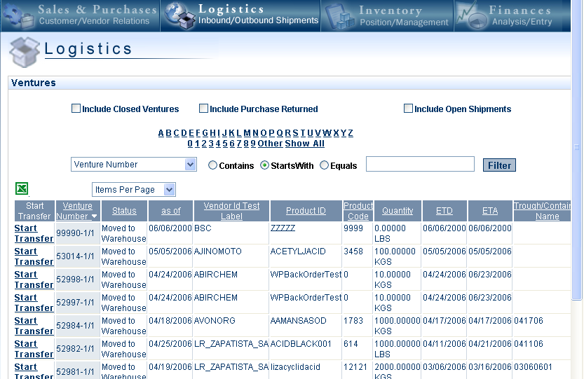

Select the Warehouse FROM which you wish to transfer the Products
Select < Proceed

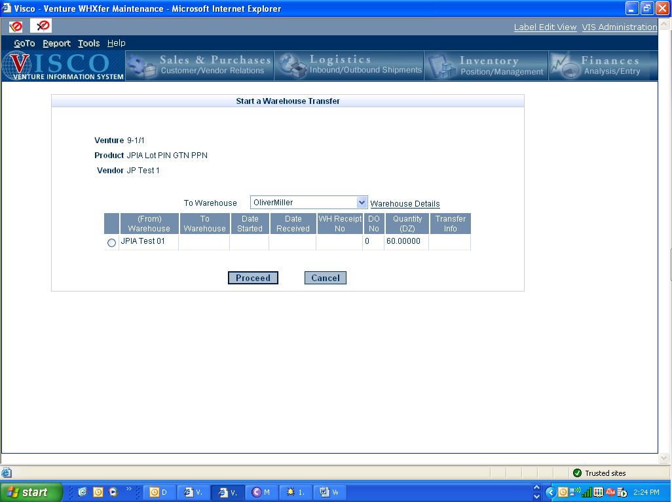

Adjust the Quantity in the Lot(s) to reflect the amount you wish to transfer, then Select < Transfer

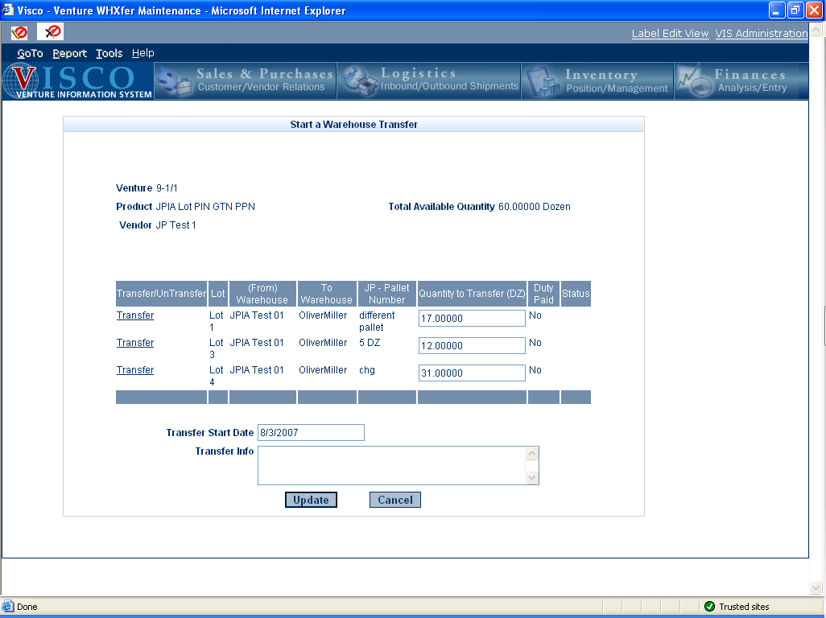
Optionally, add a description in the Transfer Text regarding the Transfer
Select < Update

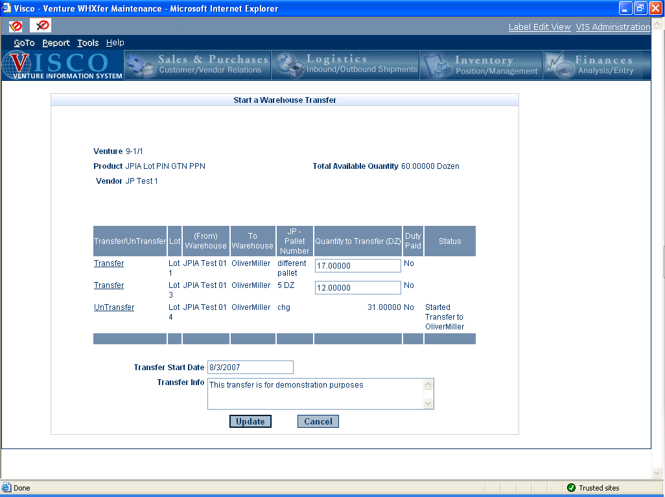

Receive a Warehouse Transfer

Inventory < Warehouse Transfers < Receive a Warehouse Transfer < Receive Transfer

Select < Receive Transfer

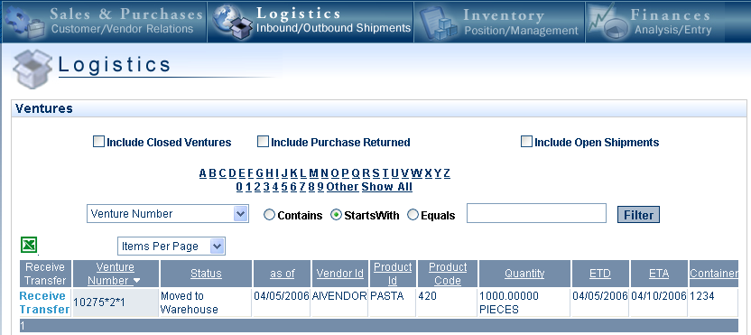

Enter Date Received & Warehouse Receipt Number*

Select < Receive

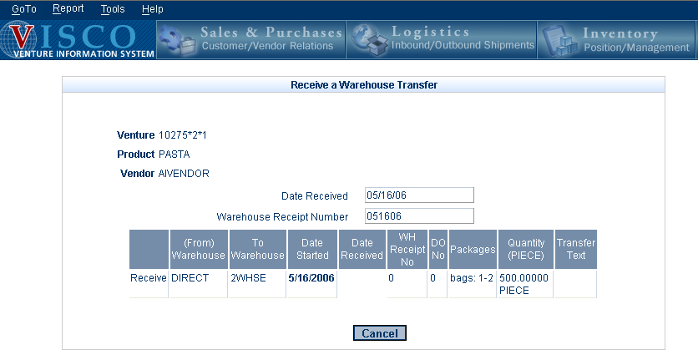

Confirming a Warehouse Transfer has successfully completed

Inventory < View Packing List

Select < View

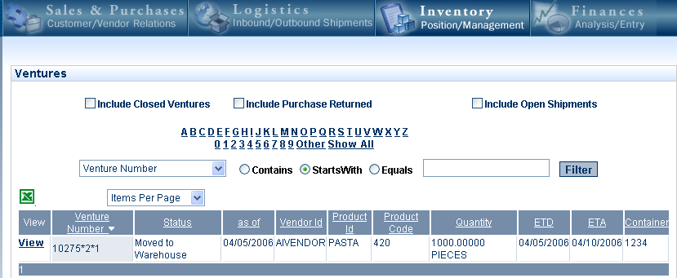

Select < Warehouse Transfers tab



